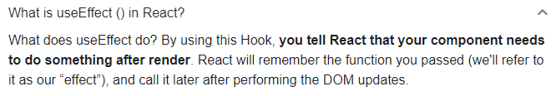

**useEffect - Basics**

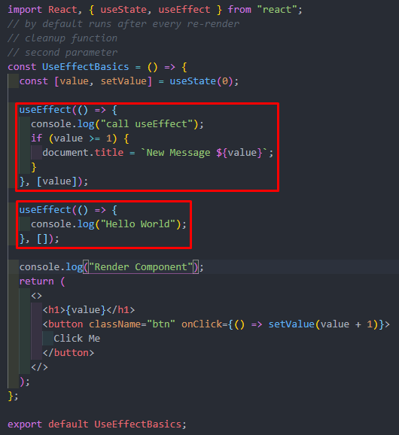



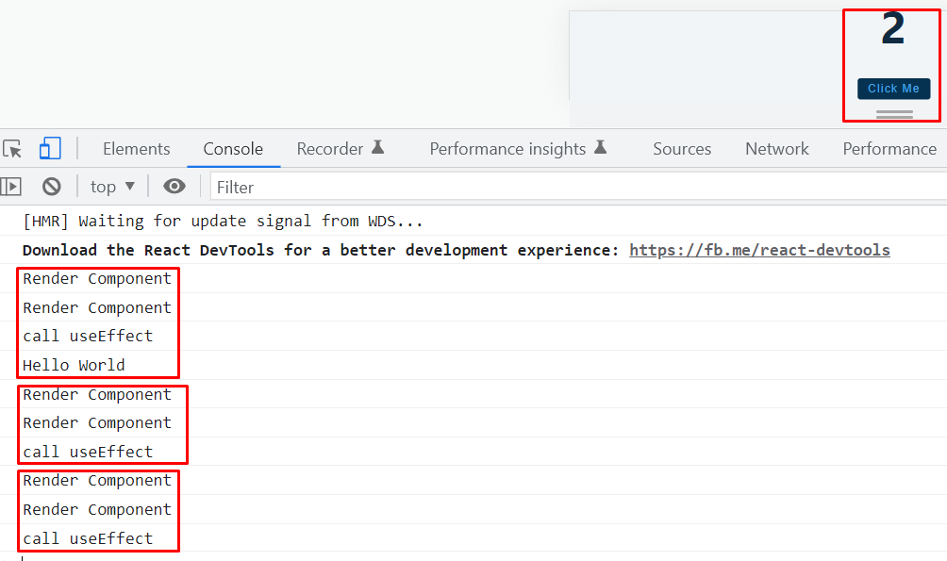

*Here, If we click then the first effect will be rendered and the second effect will be rendered as well.

*But up next, only the first effect will be rendered not the second one.

**useEffect - cleanUp Function:**

*Article:* <https://blog.logrocket.com/understanding-react-useeffect-cleanup-function/#:~:text=What%20is%20the%20useEffect%20cleanup,itself%20using%20the%20cleanup%20function>.

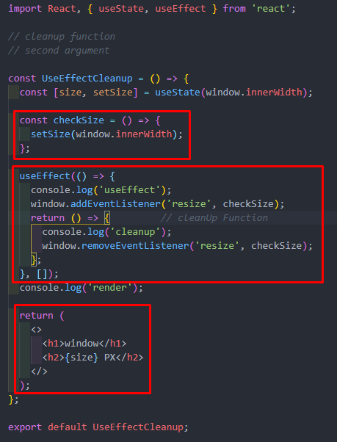

**useEffect - Fetch Data**



